

PROBABILITY AND STATISTICS FOR MACHINE LEARNING - 1BMATAI301
NAME : M YUKTHI
SEC : AIML-02

Steps to experiment on web application:



1. Open the Binomial module in your Web application.

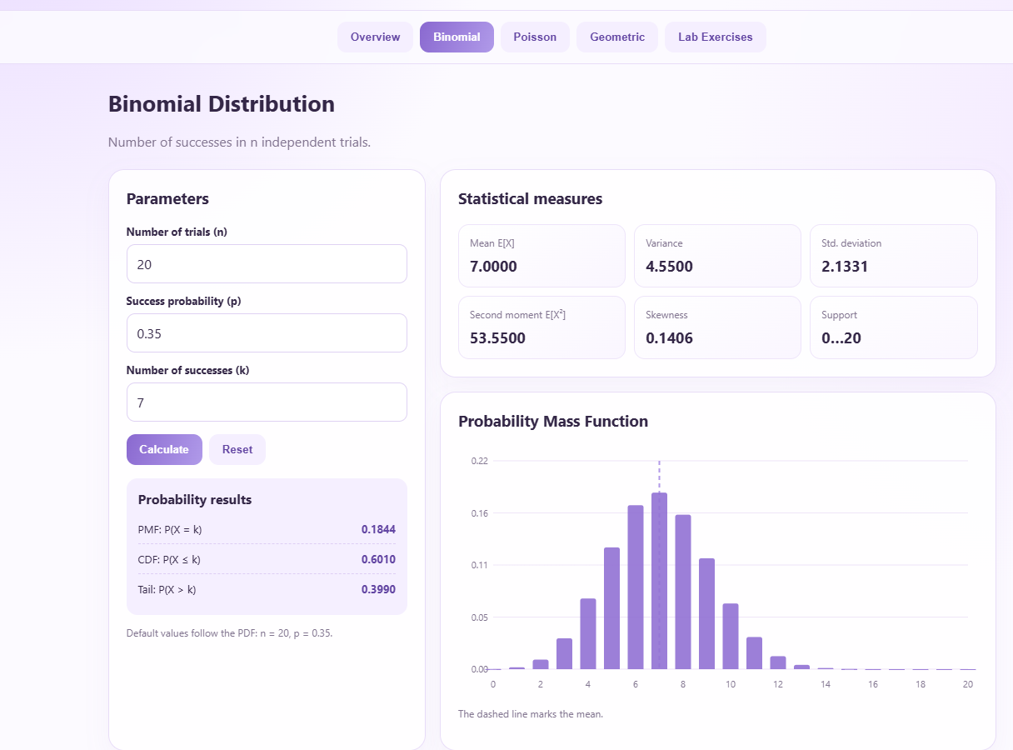

The Binomial module was opened in the web application to study the probability of defective products during quality inspection. This module helps calculate the expected number of defects, variance, and the probability of obtaining a specific number of defective products within a fixed number of trials.

2. Enter n = 20 and p = 0.05.

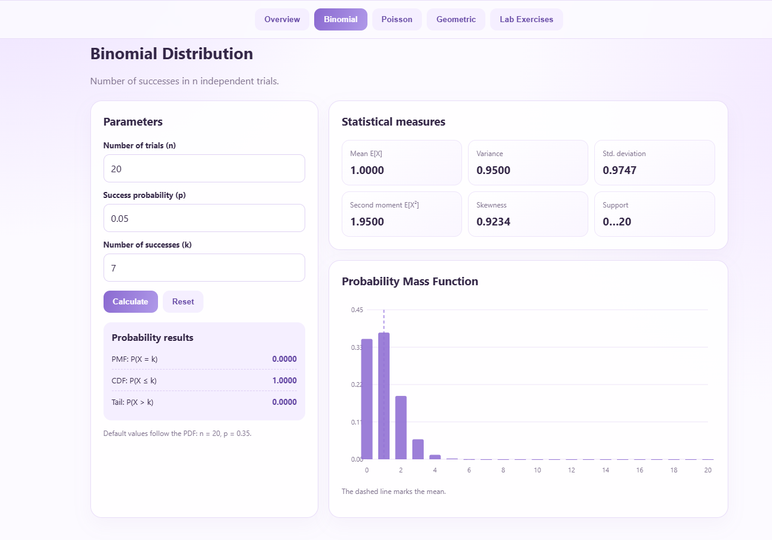

The number of trials was entered as (n=20), and the probability of finding a defective product was set to (p=0.05). Here, (n) represents the total number of products inspected, and (p) represents the probability that a product is defective. These input values were used to analyse the quality of the products.
3. Calculate the mean, variance, and probability of exactly 2 defects

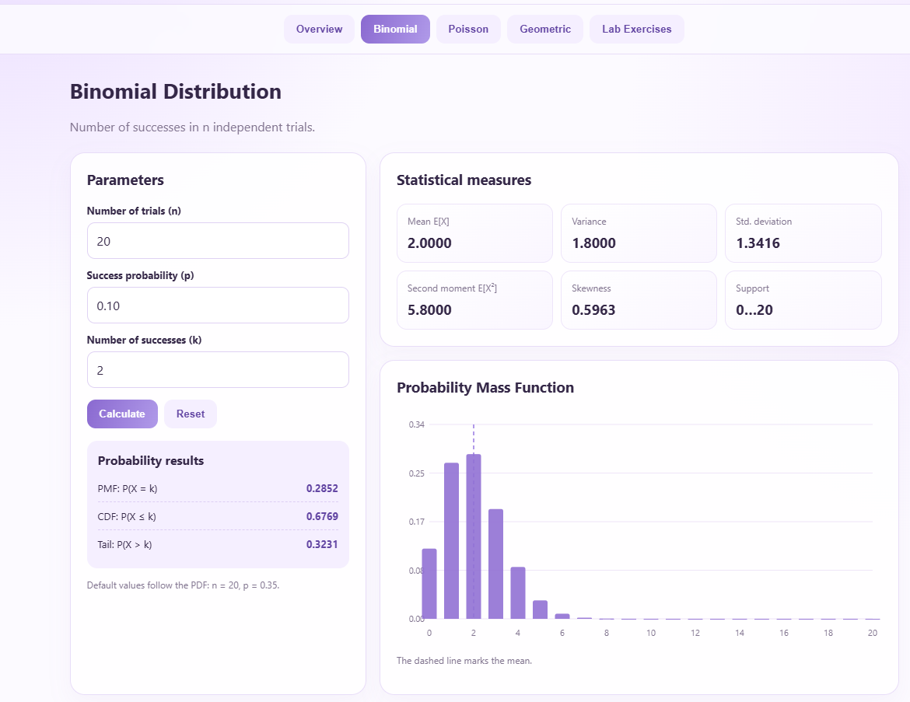

After entering the required values, the application was used to calculate the mean, variance, and probability of finding exactly two defective products. The mean was calculated as (np=1), and the variance was calculated as (np(1-p)=0.95). The probability of exactly two defects was approximately (0.1887), or 18.87%. These results help estimate the expected defect count and understand the likelihood of observing two defective products in the sample.
4. View the PMF graph. The horizontal axis represents the number of defects and the vertical axis represents the probability of each count.

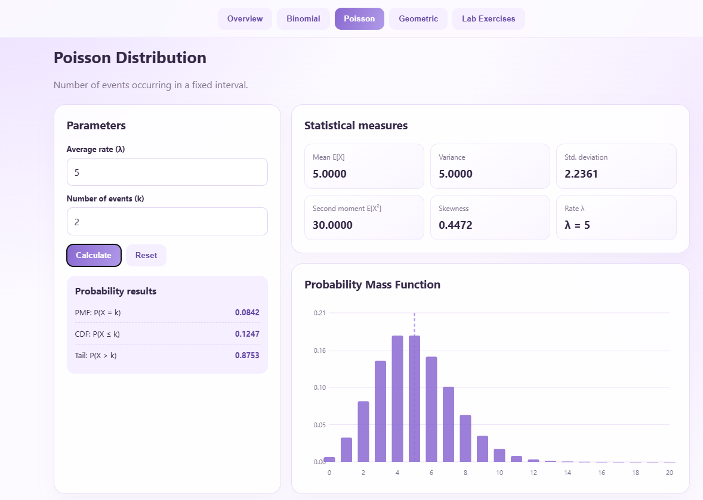

The Probability Mass Function (PMF) graph was displayed to visualize the probability associated with each possible number of defective products. The horizontal axis represents the number of defects, while the vertical axis represents the corresponding probability. The graph helps identify which defect counts are more likely to occur. Since the defect probability is low, smaller defect counts are more likely than larger ones.

5. Change the defect probability from 0.05 to 0.10 . Observe how the distribution shifts toward larger defect counts

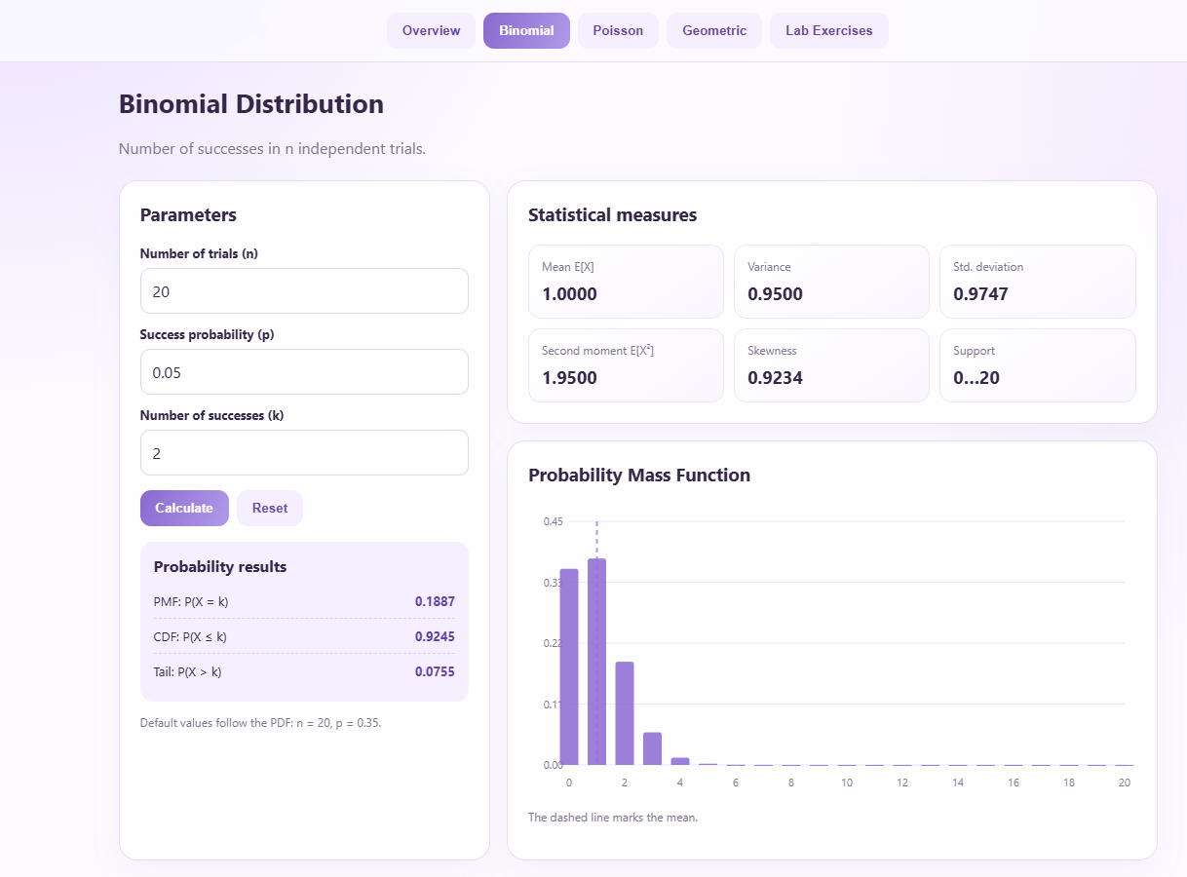
The defect probability was changed from (0.05) to (0.10), while the number of trials remained fixed at 20. After updating the value, the mean increased from 1 to 2, and the variance increased from 0.95 to 1.8. The probability of exactly two defects also increased to approximately (0.2852), or 28.52%. The graph shifted towards larger defect counts, showing that a higher defect probability increases the likelihood of finding more defective products.
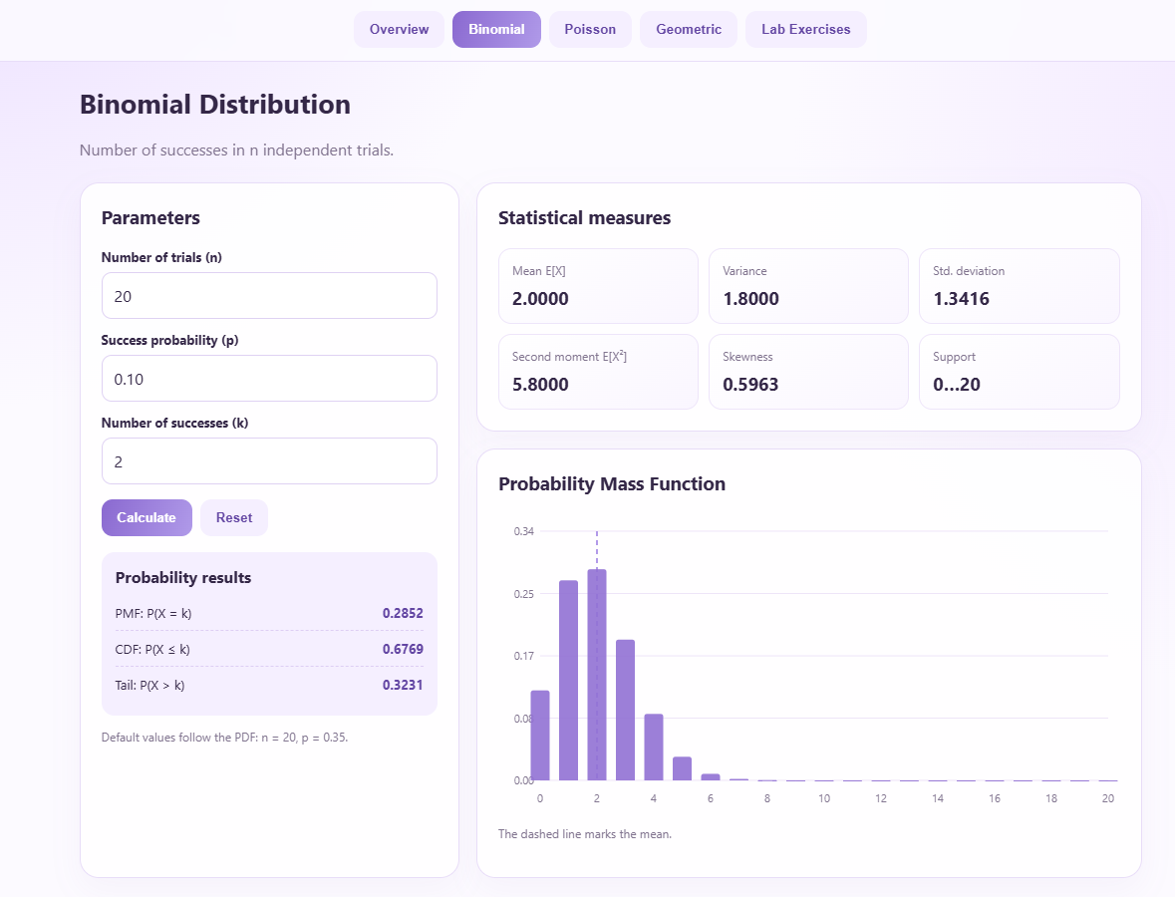

6. Open the Poisson module and enter lambda 5 for 100 inspected products. Compare the Poisson probabilities with the Binomial results.

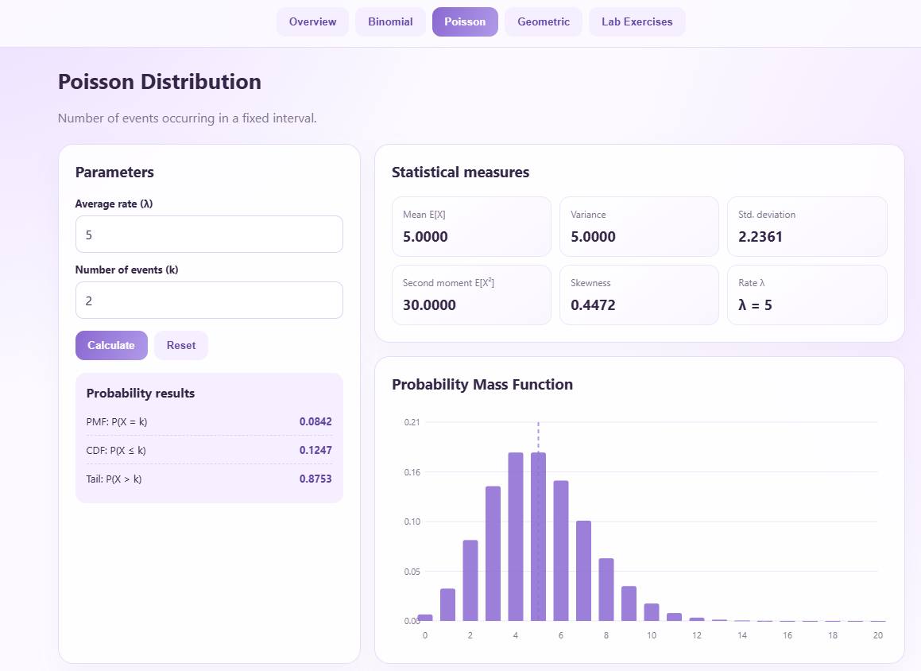

The Poisson module was opened to estimate the probability of different defect counts among 100 inspected products, using an average defect rate of (\lambda=5). The mean and variance of the Poisson distribution were both equal to 5. The probability of finding exactly two defects was approximately (0.0842), or 8.42%. When compared with the Binomial distribution using (n=100) and (p=0.05), the probability was approximately (0.0812). The close values show that the Poisson distribution provides a reasonable approximation to the Binomial distribution for these parameters.

7. Open the Geometric module and enter p=0.05. Examine the probability of detecting the first defect on different inspection attempts.



The Geometric module was opened to study the probability of detecting the first defective product on different inspection attempts. The probability of detecting a defect in each attempt was set to (p=0.05). The probability mass function used was (P(X=k)=(1-p)^{k-1}p), where (k) represents the attempt on which the first defect is detected. The probability was 0.0500 on the first attempt, 0.0475 on the second attempt, and 0.0315 on the tenth attempt. The mean number of attempts until the first defect is detected was 20, with a variance of 380.

8. Write down the numerical results, graph observations, and an inference about the quality-control process.

Numerical Results, Graph Observations, and Inference
1. Numerical Results
For the geometric distribution, let the probability of finding a defective product be \(p=0.05\).
The probability mass function is:

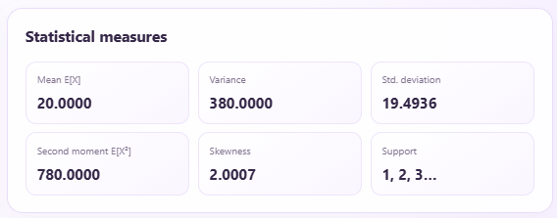

Attempt (k) | Probability (P(X=k))
1 | 0.0500
2 | 0.0475
3 | 0.0451
4 | 0.0429
5 | 0.0407
10 | 0.0315

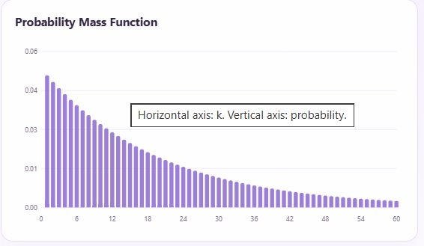

2. Graph Observations
- The graph shows the highest probability at the first attempt.
- The probability decreases as the number of attempts increases.
- The distribution is right-skewed, with probabilities gradually decreasing for later attempts.
- Since \(p=0.05\), a defective product is unlikely to be found in any single inspection attempt.

3. Inference About the Quality-Control Process
The geometric distribution indicates that the probability of detecting a defective product on each inspection attempt is low. On average, 20 attempts are required to find the first defective product. Therefore, the quality-control process may need improved inspection methods or more effective defect-detection techniques to identify defective products sooner and improve product quality.

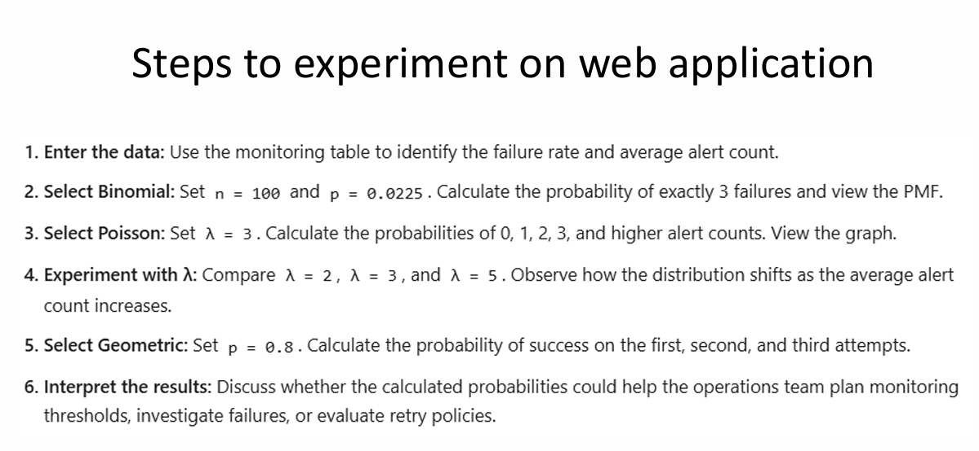

- Enter the data
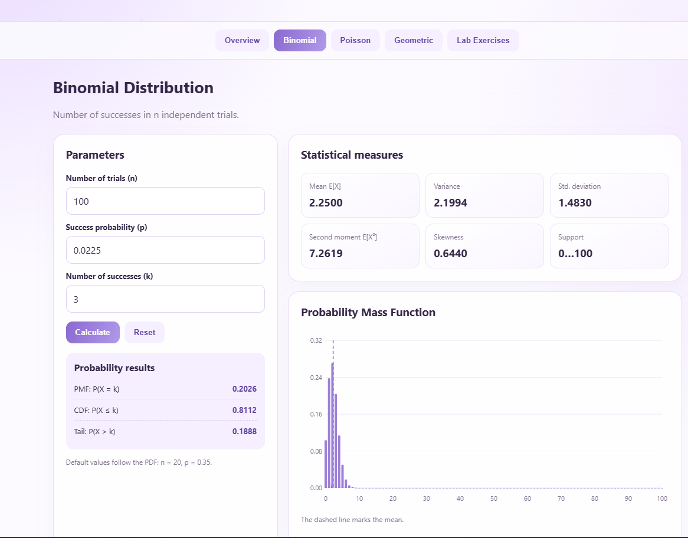
- Binomial Distribution

Graph observation: The PMF graph represents the probability of different numbers of failures among 100 trials. The distribution is concentrated around smaller failure counts.

Inference: The Binomial distribution helps estimate the probability of a specific number of failures in a fixed number of monitoring events.

- Poisson Distribution

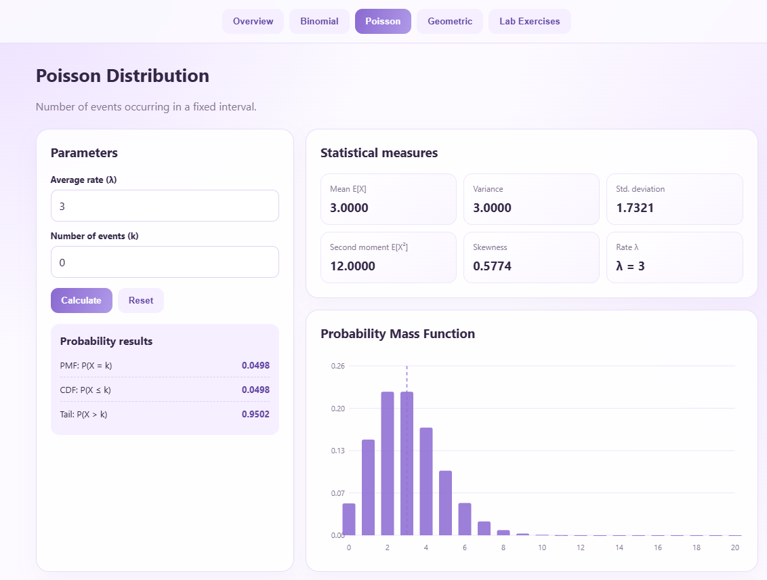

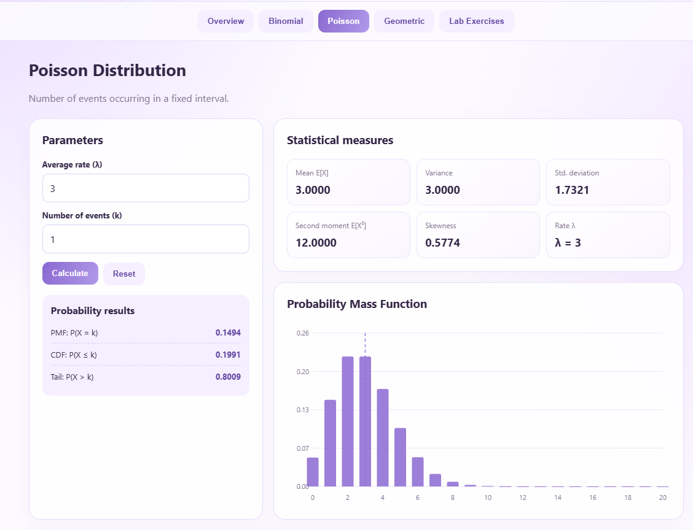
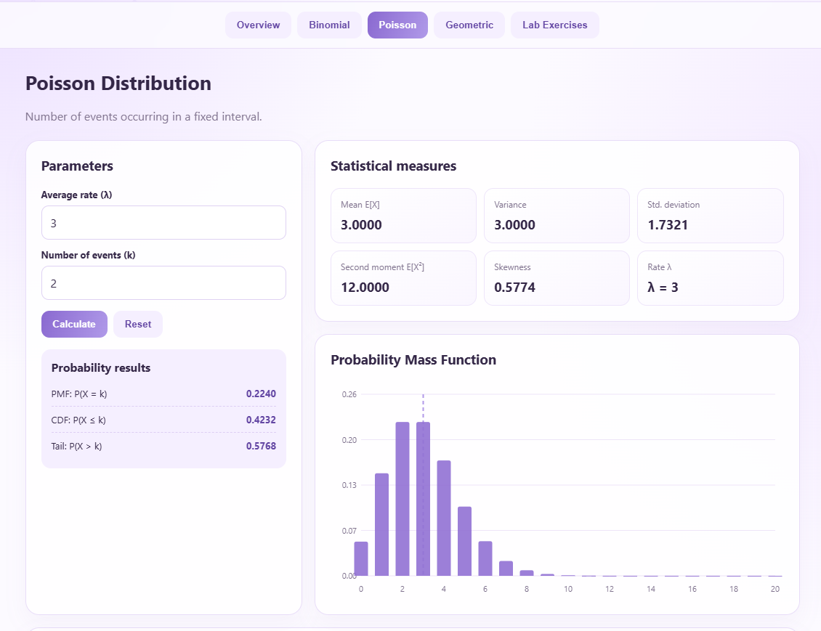
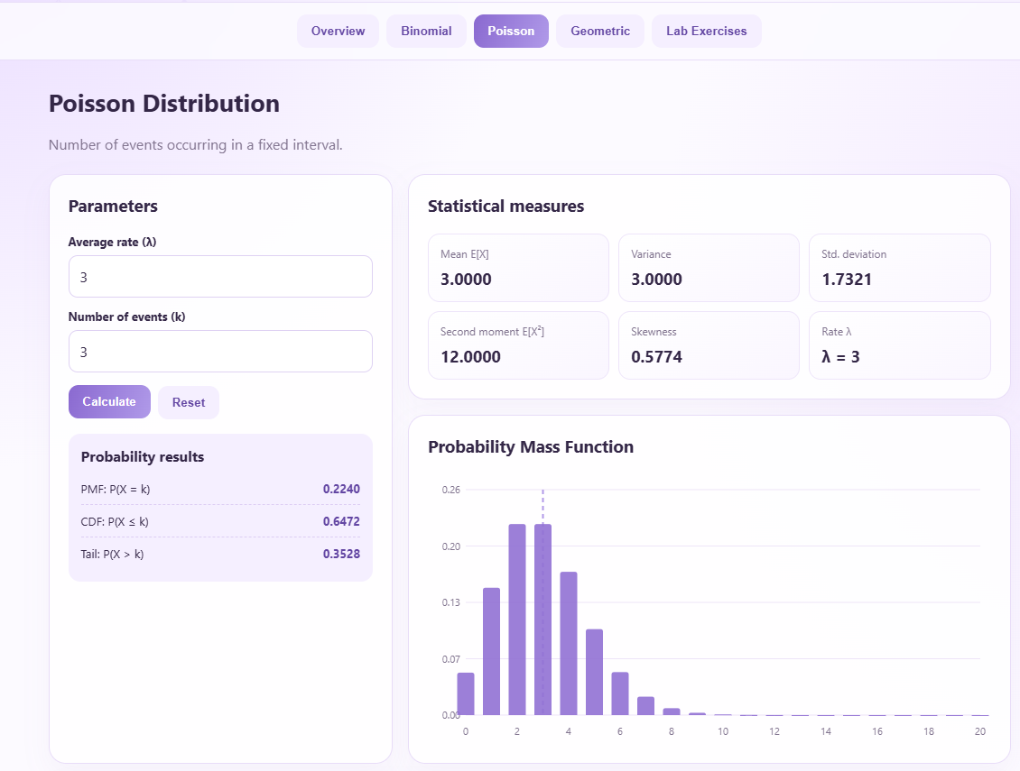

Graph observation: The highest probabilities occur around 2 and 3 alerts.

Inference: The Poisson distribution helps estimate alert frequencies and identify unusually high alert counts that may require investigation.

- Compare Different Poisson Parameters
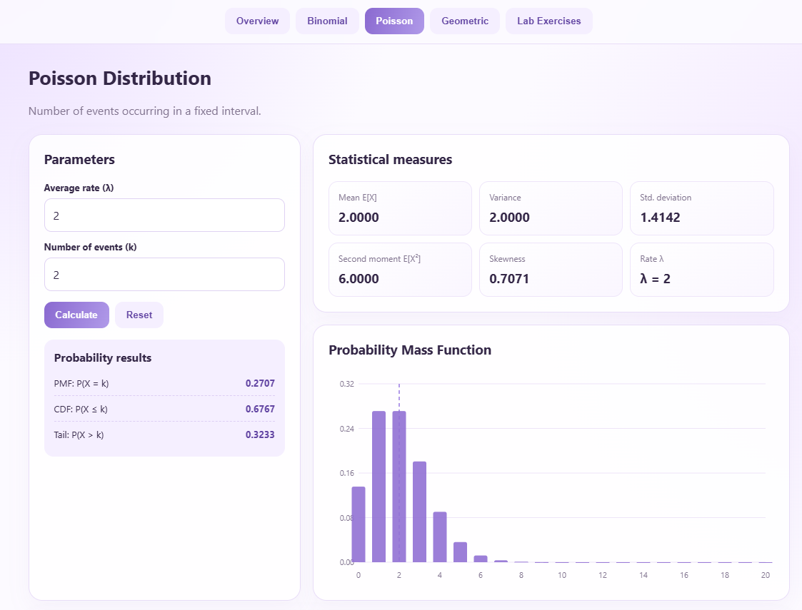

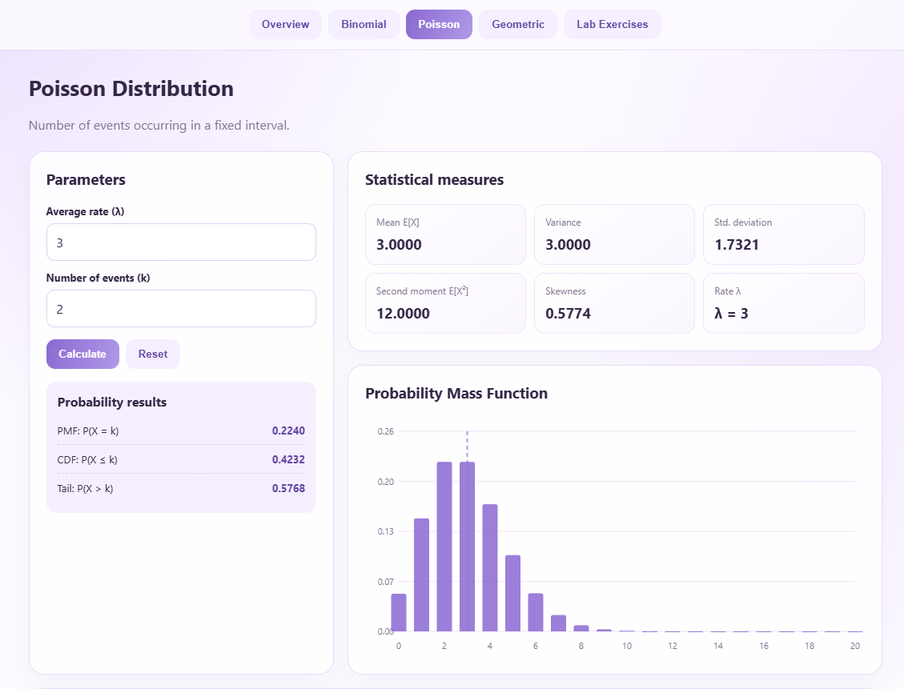

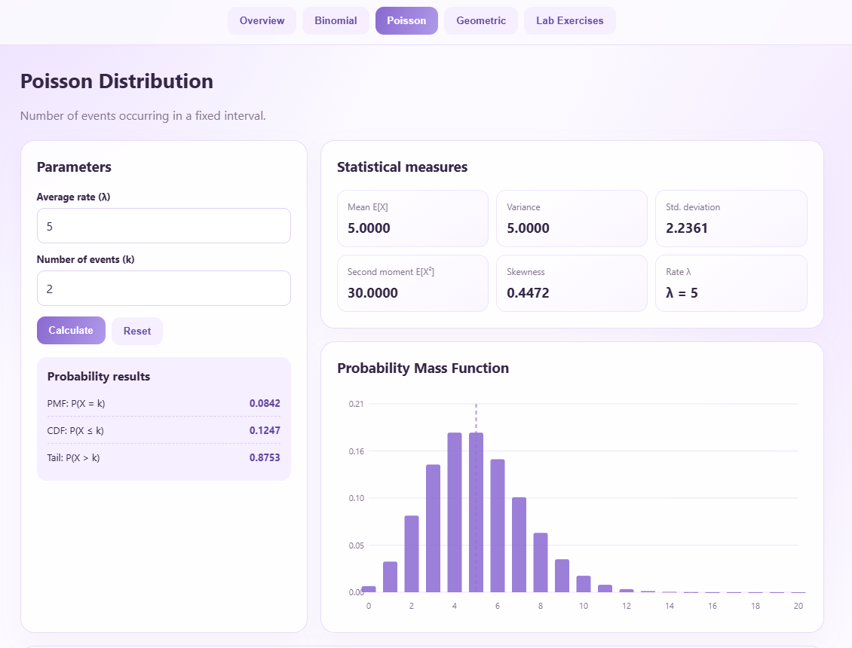

Graph observation: As \(\lambda\) increases, the graph shifts towards larger alert counts.

Inference: Comparing Poisson distributions helps the operations team understand how increasing alert frequency affects system monitoring and set suitable alert thresholds.

- Geometric Distribution
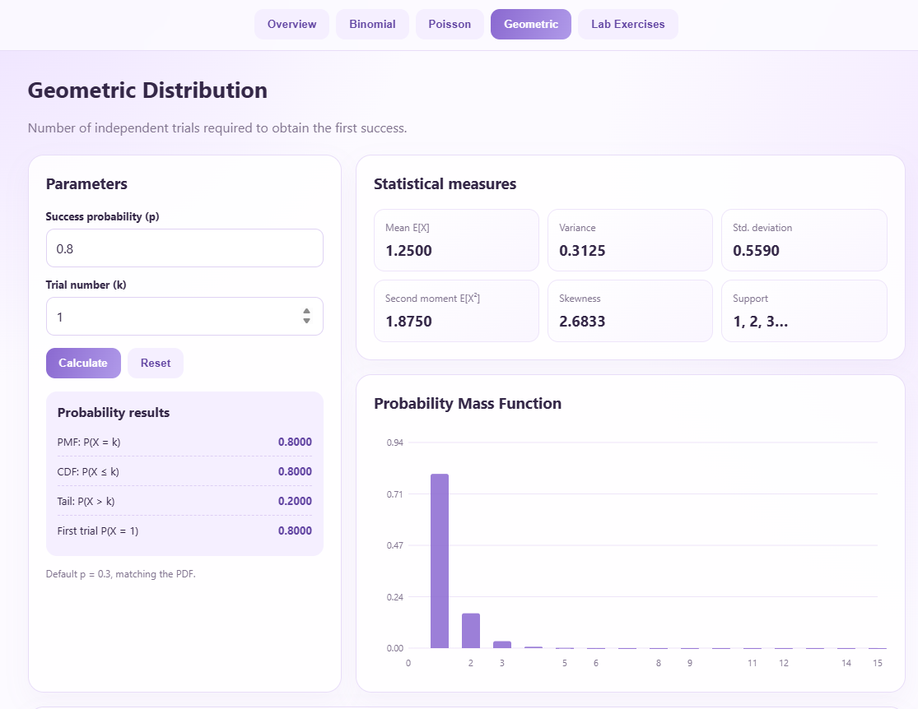

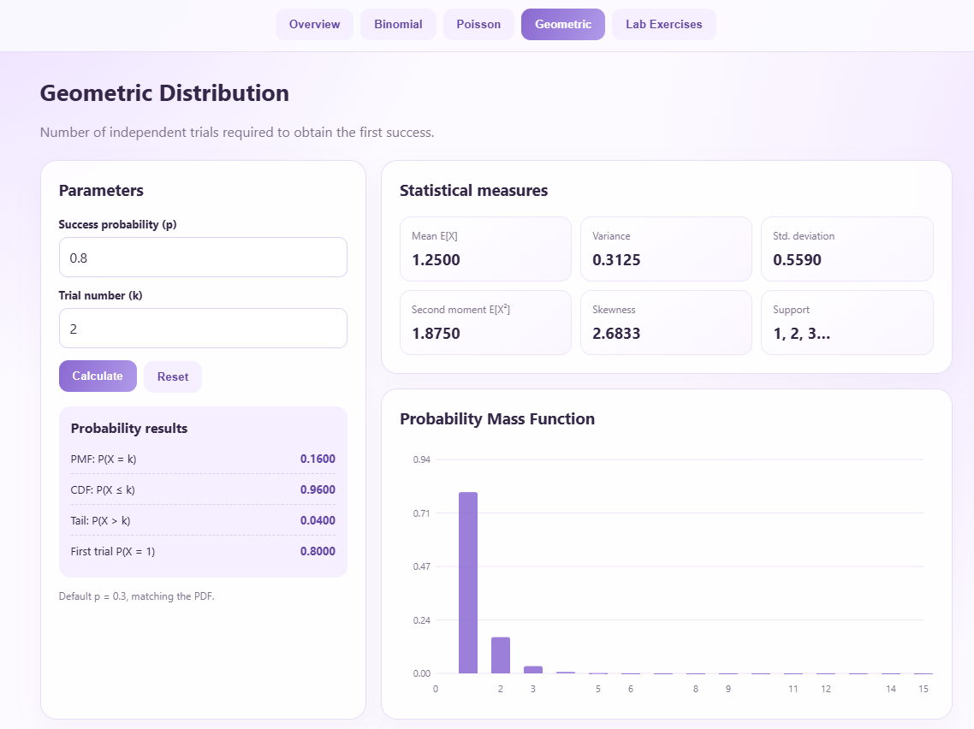
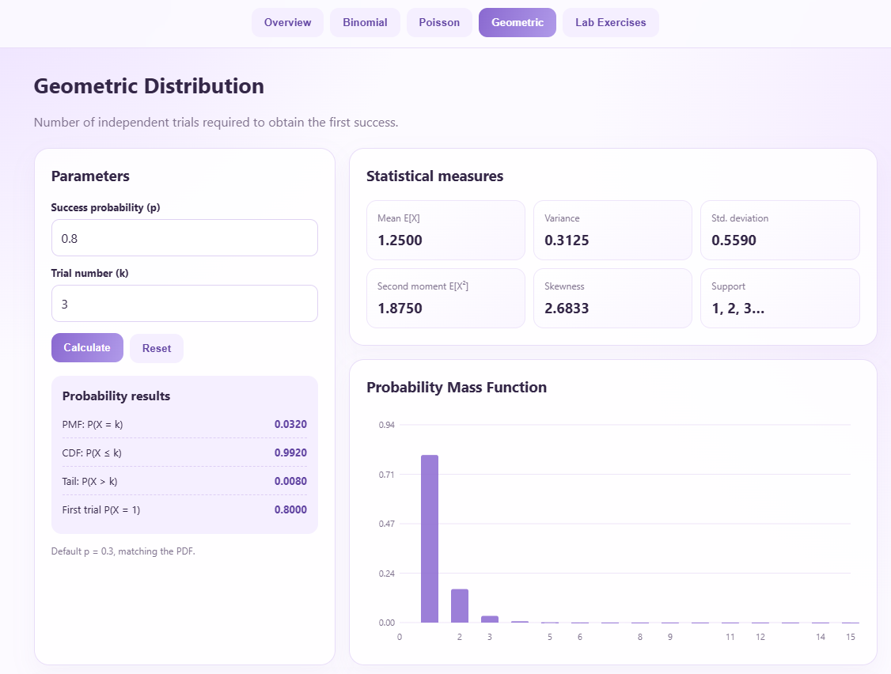

Graph observation: The probability is highest on the first attempt and decreases rapidly on subsequent attempts because the probability of success on each attempt is 0.8.
Inference: The Geometric distribution indicates that success is highly likely on the first attempt. In a monitoring system, this model can help evaluate the likelihood of successful detection or recovery on successive attempts, provided that each attempt has the same success probability and is independent of the others.

- Interpret the Results

Step 6: Interpretation of Results
1. Binomial Distribution: The Binomial distribution, with (n=100) and (p=0.0225), gives a mean of 2.25 failures and a probability of approximately 0.2026 (20.26%) for exactly three failures. This helps estimate the likelihood of failures occurring in a fixed number of monitoring events.

2. Poisson Distribution: For (\lambda=3), the probabilities of different alert counts were calculated. The probability of exactly three alerts is approximately 0.2240 (22.40%). When (\lambda) increases from 2 to 5, the distribution shifts towards higher alert counts. This helps the operations team understand changes in alert frequency and establish suitable monitoring thresholds.

3. Geometric Distribution: For (p=0.8), the probability of success on the first attempt is 0.80, on the second attempt is 0.16, and on the third attempt is 0.032. This shows that success is most likely on the first attempt and becomes less likely on later attempts, assuming independent attempts with a constant success probability.

Overall Inference: The Binomial distribution helps estimate the number of failures in a fixed number of trials, the Poisson distribution helps analyse alert frequencies, and the Geometric distribution helps estimate the attempt on which the first success occurs. These results can help the operations team identify unusual failure patterns, plan monitoring thresholds, investigate repeated failures, and evaluate retry policies. Therefore, probability distributions provide useful statistical support for improving system monitoring and reliability.

